 | 
PANEL ASSESSMENT BRIEFING REPORT
HUNTER AND CENTRAL COAST REGIONAL PLANNING PANEL

PANEL REFERENCE & DA NUMBER | PPSHCC-172  DA/2087/2018/REV
PROPOSAL | 3 into 1,079 Lot Torrens Title Subdivision
ADDRESS | Lot 2 DP 877349, Lot 1 DP 1156243, Lot 100 DP 1252590 and Lot 22 DP 816113  10, 10C and 144 Woodford Street, Cameron Park  M1 Pacific Motorway, Lake Macquarie
APPLICANT | Winten (No 21) Pty Ltd
OWNER | Winten (No 21) Pty Ltd  Transport for NSW  Lake Macquarie City Council
DA LODGEMENT DATE | 22 November 2018
REVIEW LODGEMENT DATE | 2 February 2023
REGIONALLY SIGNIFICANT CRITERIA | Clause 2, Schedule 7 of the SRD SEPP – General development over $30 million
CIV | $116 million (excluding GST)
CLAUSE 4.6 REQUESTS | N/A
KEY SEPP/LEP | Concept Plan MP10_0090 – Minmi, Link Road North and South Residential Development (Northern Estates)
TOTAL & UNIQUE SUBMISSIONS | Notification under the original application:  - 5 December 2018 – 14 January 2019  - 6 October 2020 – 26 October 2020  - 30 July 2021 – 20 August 2021  - 3 June 2022 – 28 June 2022  Notification under the review application:  - 6 February 2023 – 28 February 2023  - 6 October 2023 – 27 October 2023  - 1 November – 22 November 2023  Council have received six unique objections to the original rounds of notification.  Five objections were received in response to notifications under the review.
BRIEFINGS | Briefings held for the review application:  - 2 June 2023  - 25 July 2023  - 9 October 2023  - 28 November 2023
RECOMMENDATION | Approval
ATTACHMENTS | Attachment A: Concept Approval assessment  Attachment B: Urban Design Guideline assessment  Attachment C: Draft conditions of consent
DRAFT CONDITIONS TO APPLICANT | Yes – 6 December 2023
SCHEDULED MEETING DATE | 13 December 2023
PREPARED BY | Jonathan Ford, Senior Development Planner
DATE OF REPORT | 6 December 2023

EXECUTIVE SUMMARY
- The proposal
The proposal seeks consent for a subdivision of three into 1079 lots, comprising 1058 residential lots, four future development lots including a school site, 16 public/drainage reserves and one residual lot. The application also includes site preparation works including earthworks, clearing of vegetation, contamination remediation and subsidence mitigation works, construction of roads, drainage and utility infrastructure, landscaping to streets, drainage reserves and public reserves and intersection and road network upgrades.
The development application relates to a majority of Stage 5 of the state Concept Approval (MP10_0090), with the remainder of Stage 5 contained within the Newcastle local government area (LGA) and subject of a concurrent review application being considered by the Hunter and Central Coast Regional Planning Panel (RPP).
Several key constraints are applicable to the site and development, including:
- Concept Approval consistency
- Aboriginal heritage
- acoustic impact
- biodiversity
- bushfire protection
- contamination
- earthworks
- mine subsidence
- stormwater management and flooding
- Summerhill Waste Management Centre impacts
- traffic impact
- urban design
- utilities and servicing
It is considered that matters have been resolved to a satisfactory standard subject to the imposition of conditions at Attachment C of this report. The application is recommended for conditional approval.
- THE SITE AND LOCALITY
  - Site context and locality
The site is located in the suburb of Cameron Park, within the Lake Macquarie City Council (LMCC) LGA.
The northern boundary of the site adjoins the LGA boundary between LMCC and City of Newcastle (CN). Approximately half of the northern boundary of this site is shared with other lands that are owned by the same developer and are subject to a review application for subdivision with CN (RE2023/00003).
The other main portion of the northern boundary is shared with Blue Gum Hills Regional Park (BGHRP). This Park is administered by the National Parks and Wildlife Service (NPWS). The remaining part of northern boundary is shared with Summerhill Waste Management Centre (SWMC) which is owned and operated by CN.
To the east is a large landholding that was formerly owned by a mining company. This land is now owned by a developer and is commonly known as Eden Estates. Both LMCC and CN are in discussions with this developer in regard to rezoning the land and a significant residential subdivision.
To the west of the site is Woodford Street and Transport for NSW (TfNSW) land holdings. The Cameron Park industrial estate and the Newcastle Link Road / Pacific Motorway interchange are also to the west.
The southern boundary of the site is a ridgeline of which the Newcastle Link Road runs east-west along. The Cameron Park residential estate is located on the southern side of the road, which includes the undeveloped Link Road South development owned by the developer proposing this development.
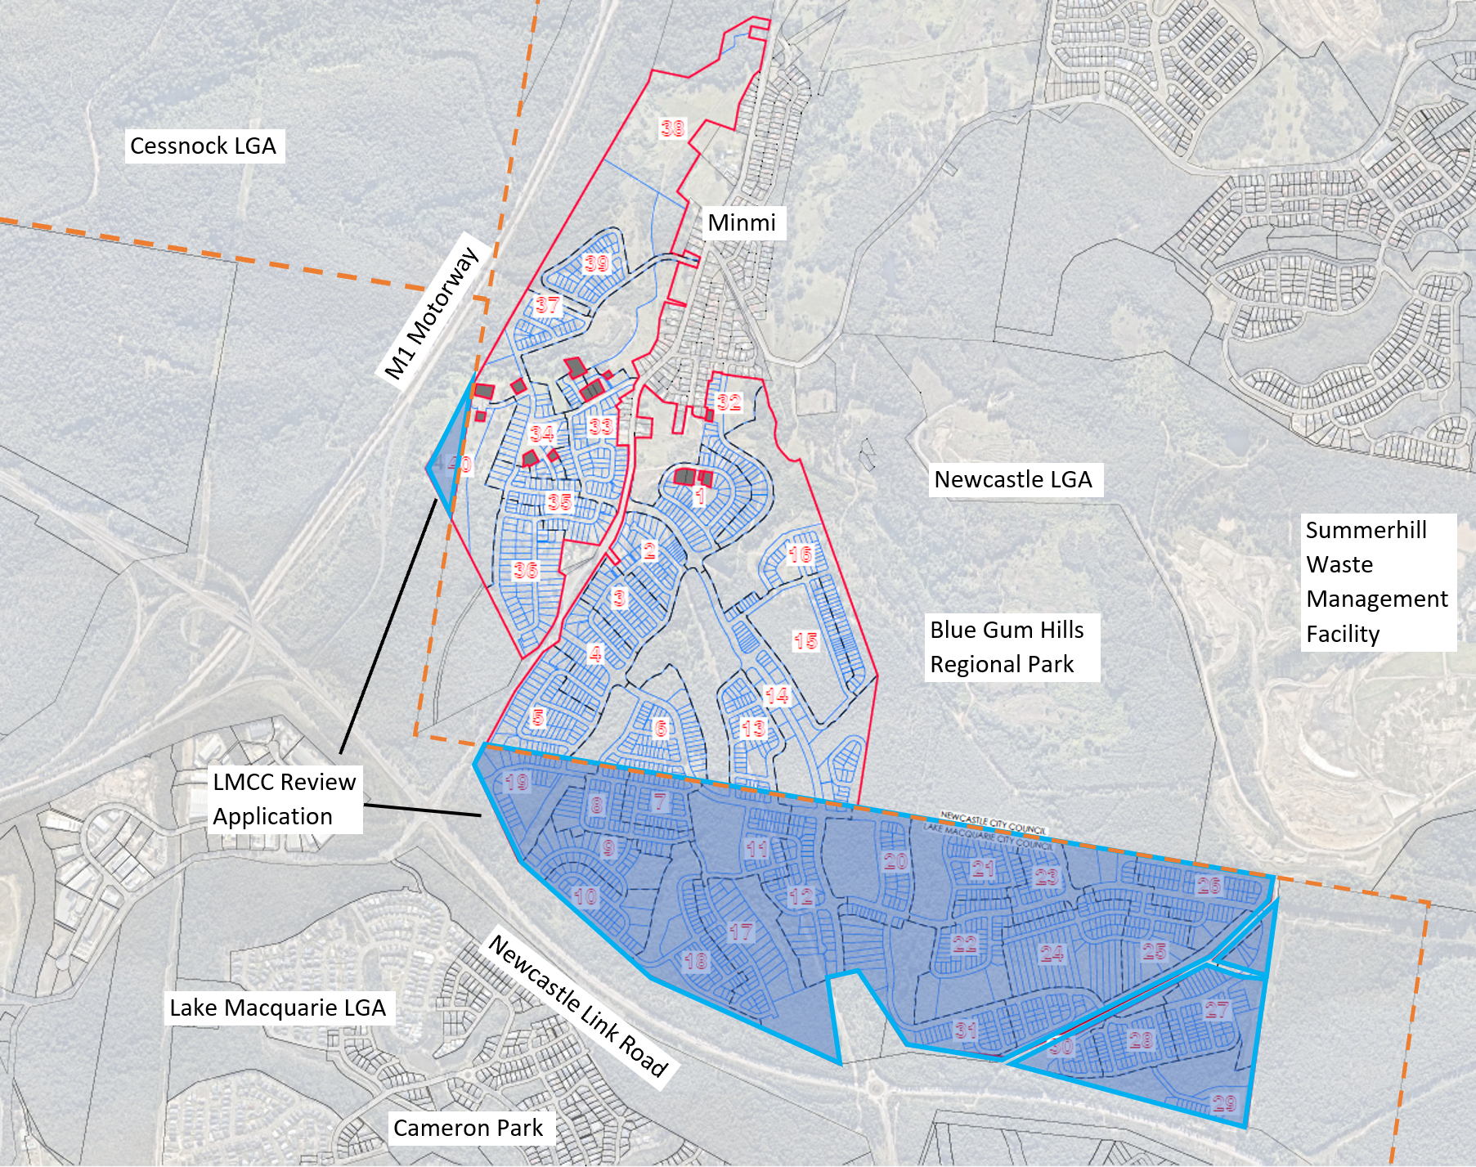
Figure 1: Site context
1.2 Site background
The site forms part of Concept Plan MP10_0090 which was approved by the Planning Assessment Commission in 2013 for a five-stage development of up to 3,300 dwellings and two commercial centres across the 520-hectare site, including associated infrastructure.
The Concept Approval also required the dedication of 1,561 hectares of conservation lands. A Voluntary Planning Agreement (VPA) was entered into with the State Government for the environmental conservation land contribution of the 1,561 hectares. This land was transferred to the State Government in October 2016.
The Concept Approval was modified on 21 December 2016 to adjust the timing of the provision of certain documents.
A second VPA was entered into with the Minister for Planning in 2018 for the provisions of contributions for designated state infrastructure including monetary contribution, dedication of education lands, and dedication of regional open space. Monetary contributions have been paid, and dedication of land will occur as part of the development process.
Consent has been issued for Stage 1 within CN LGA and works have commenced. Stage 2 within LMCC LGA was approved by the Land and Environment Court (LEC) in December 2017 for 617 lots and works have not commenced as the consent is effectively being held in abeyance pending resolution of traffic matters to satisfaction of TfNSW. A modification has been lodged to this application to amend the relevant condition to enable works to commence; this is facilitated by the state having the state VPA amended.
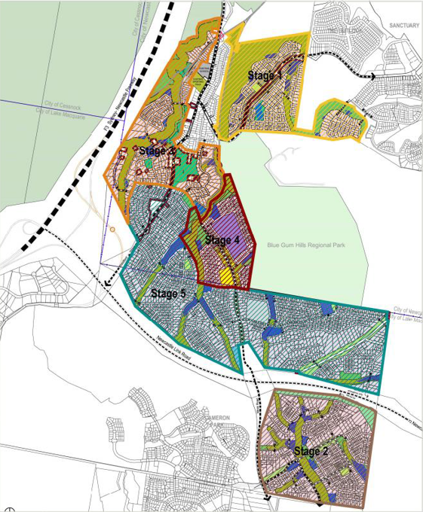
Figure 2: Minmi / Link Road Concept Approval (MP10_0090)
1.3 The site
The site is generally rectangular in shape (approximately 2500m x 800m) with an area of 160 hectares. The land is densely vegetated native bushland, with some cleared areas for fire trails and tracks.
An unformed public road is located in the eastern part of the site. This road was previously a Crown Road and was transferred to LMCC as a public road in 2008.
The site is traversed by three overhead transmission lines. An easement on the eastern boundary of the site contains a TransGrid 330KV transmission line. An Ausgrid transmission line is situated within the unformed public road reserve, while the other connects via the road at Newcastle Link Road towards Minmi township.
Topographically, a prominent ridgeline defines the southern boundary, with the site generally falling to the north. The site drains south to north via four main flow paths. The flow paths are ephemeral tributaries of Back Creek. Approximately 20% of the eastern portion of the site drains to the east into Maryland Creek. The higher portions of the site contain slopes over 25%.
The site is bushfire prone from adjacent bushland surrounding the site and from bushland on the site. The site is not flood prone but will experience a level of flooding from on-site ephemeral creek lines.
The site has a history of underground coal mining and is subject to mine subsidence. No surface workings occurred on the site but the site did contain shafts down to underground workings. Some contamination remains on site, such as coal contained in fill used to cap shafts and possible debris from a demolished former mine building. Other contamination exists due to opportunistic dumping of household and building waste.
Several Aboriginal sites were identified within the site in 2011 but subsequent attempts to find these sites were unsuccessful and only one site adjacent to the northern boundary remains.
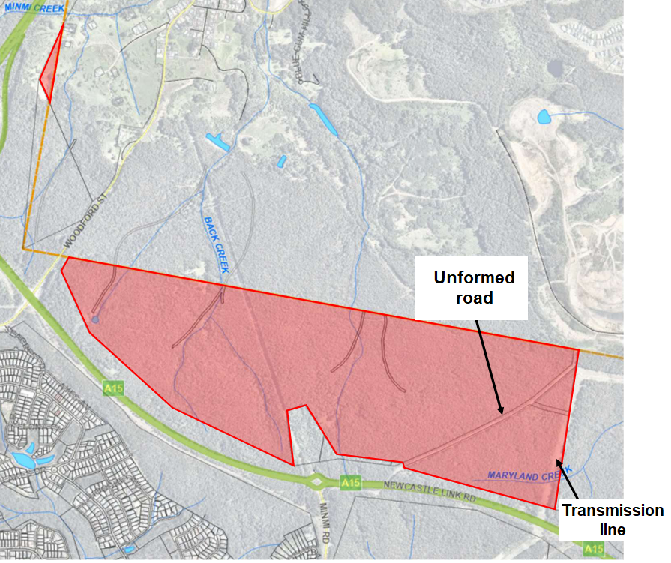
Figure 3: The site
- THE PROPOSAL
  - The proposal
The proposal seeks consent for subdivision of three lots into 1079 lots, comprising:
- 1058 residential lots
Comprising 938 standard lots ranging from 450m² to 1.9 hectares and 120 small lots ranging between 379m² and 450m².
- 4 future development lots
- Lots 1736 and 1930 are identified for future residential development.
- Lot 1201 is split zoned residential/local centre and shares its northern boundary with CN LGA boundary.
- Lot 2046 is identified for a potential school site.
- 16 public/drainage reserves
- Lots 1851 and 2547 are identified for local parks.
- Lot 3050 will be created as a landscape buffer to the existing unformed road reserve.
All reserves will be dedicated to Council for ongoing management.
- One residual lot adjoining the Newcastle development area (Lot 4003);
- clearing
- bulk earthworks
- roads
- stormwater infrastructure, including bioretention basins and swales, to be dedicated to Council
- utilities
- landscaping to public domain areas, including street tree planting, bioretention planting and planting of batters/embankments.
Additional works associated with servicing the development are proposed including relocation of electricity infrastructure, sewer and water infrastructure, traffic upgrades, recreation facilities and existing road network upgrades.
The development is proposed to be constructed over 21 stages. The stage numbering is not consecutive and some stages may be completed concurrently.
The application relates to a majority of stage 5 of the Concept Approval.
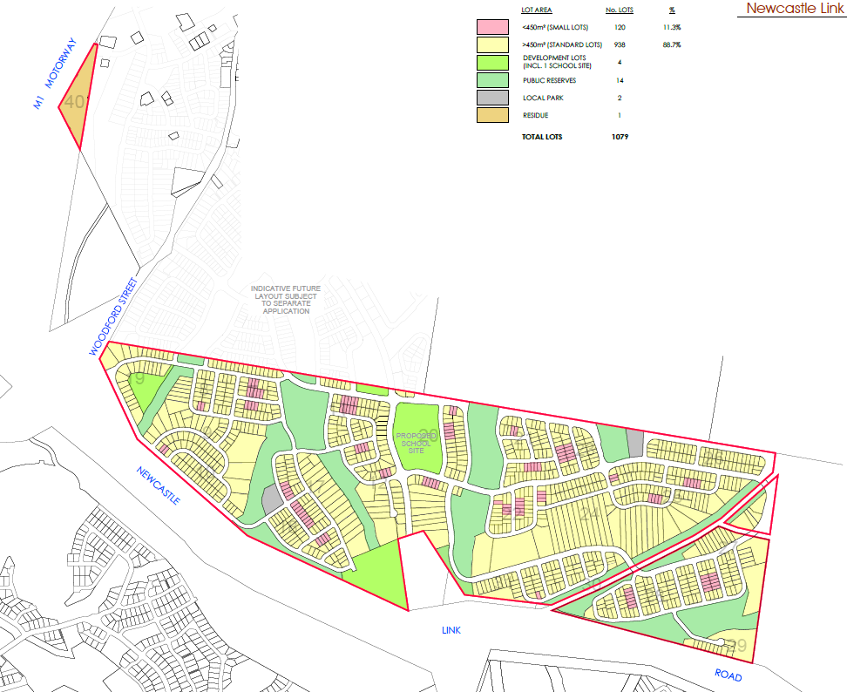
Figure 4: Proposed subdivision
  - Application chronology
The subject application is a review of a refusal decision by the RPP for development application DA/2087/2018 in accordance with Section 8.2 of the Environmental Planning and Assessment Act 1979. The original development application was lodged on 22 November 2018. The refusal decision for the application was issued on 13 December 2022. The applicant subsequently lodged the subject review application on 2 February 2023.
A chronology of the application since lodgement of the original application is outlined below.
Table 1: Application chronology
Date | Event
22 November 2018 | Original application lodgement date
13 December 2022 | RPP determination decision - refusal
2 February 2023 | Lodgement of Section 8.2 review application with LMCC
6 February – 28 February 2023 | Notification of review application
6 February 2023 | Internal and external referrals issued
5 April 2023 | Further information submitted by applicant regarding ‘uplisted’ flora and fauna species and public domain landscaping.
17 May 2023 | Advice received from applicant of agreement with TfNSW to resolve regional traffic requirements for the development.
22 May 2023 | Partial RFI issued for matters arising from internal engineering referral.
2 June 2023 | Review application RPP Kick-off briefing.
5 June 2023 | General Terms of Approval received from Subsidence Advisory NSW.
8 June 2023 | TfNSW endorsement and recommended conditions received by Council.
26 June 2023 | Additional information provided by applicant regarding local traffic, drainage, remediation, and acoustic impact.
13 July 2023 | Further request for information issued regarding ecological impacts.
25 July 2023 | Update briefing to RPP.
29 August 2023 | Further request for information regarding residual matters.
15 September 2023 | Aggregated response to all RFIs provided by applicant.
6 – 27 October 2023 | Second round of notification (response to RFI).
24 October 2023 | Alternative arrangements for provision of recreation facilities proposed.
1 – 22 November 2023 | Third round of notification (updated recreation facilities arrangements).
27 November 2023 | Elected Council of Lake Macquarie resolved to endorse the letter of offer to enter into a VPA.
28 November 2023 | Update briefing to RPP.

  - Lake Macquarie application
The Lake Macquarie application only is being reported to the Panel for determination. Senior Counsel advice has been provided by the applicant which outlines and supports the ability for both the Lake Macquarie and Newcastle applications to be determined independently, having consideration to the Concept Approval and relevant legislation, and the substantially the same test. Council have reviewed and are supportive of the advice. A copy of this advice has also been provided to the Panel in the November 2023 briefing.
Standard subdivision development conditions of consent have been imposed that will require lots to be delivered as per the approval, which currently assumes the lots on the Newcastle application will be delivered as per the Concept Approval and align with the Lake Macquarie layout. Where approved lots are not able to achieve the requirements of any development consent granted, further investigation and potential modifications will be required. For example, for lots along the northern boundary, if an approval has not been granted for the Newcastle application. However it is understood the delivery of these lots are not incorporated into the first stages of the development to be delivered by the applicant and there will be sufficient time to investigate resolutions in the event this circumstance arises.
Conditions of consent have been imposed to ensure no works associated with the Lake Macquarie application occur on lands in Newcastle.
- STATUTORY CONSIDERATIONS
  - Environmental Planning and Assessment Act 1979
When determining a review application, the consent authority must take into consideration the matters outlined in Division 8.2 of the Environmental Planning and Assessment Act 1979 (EP&A Act) including:
Section 8.2 Determinations and decisions subject to review
The refusal decision issued by the RPP for the original application is a determination within the scope of this Section.
Section 8.3 Application for and conduct of review
The review application was lodged within the prescribed timeframe. The review is being undertaken by a RPP in accordance with sub-section (7) and the Sydney District and Regional Planning Panels Operational Procedures.
Section 8.4 Outcome of review
Council’s assessment and recommendation has been based around unresolved matters under the original application, and the associated Reasons for Refusal on the RPP’s Determination Letter.
Other considerations are outlined in accordance with general assessment obligations under Section 4.15 of the EP&A Act.
3.2 Environmental Planning and Assessment (Savings, Transitional and Other Provisions) Regulation 2017
The development is classified as a transitional Part 3A project in accordance clause 2(1)(b) of Schedule 2 of the Environmental Planning and Assessment (Savings, Transitional and Other Provisions) Regulation 2017 (the Transitional Regulations). Part 3A of the Act, as in force immediately before the repeal of that part, continues to apply to the project in accordance with clause 3(1) of the Transitional Regulations.
Section 3B(2)(d) of Schedule 2 notes a consent authority must not grant consent unless it is satisfied the development is generally consistent with the terms of the approved Concept Plan.
Section 3B(2)(f) of Schedule 2 notes the provision of any environmental planning instrument or development control plan do not have effect to the extent of any inconsistency with the terms of the Concept Approval.
Considering the updated information submitted under the review application, the development now demonstrates alignment with the terms of the approved Concept Plan. Detailed consideration against the individual Concept Approval conditions is provided in Attachment A.
3.3 Biodiversity Conservation Act (Savings and Transitional) Regulation 2017
The provisions of clause 34A of the Biodiversity Conservation Act (Savings and Transitional) Regulation 2017 apply to the development and requires consideration of impacts to biodiversity under the former planning provisions, being the Threatened Species Conservation Act 1995 (TSC Act).
Assessment under the original application resolved the development does not trigger any further assessment requirements for those species previously assessed under the 34A certification. It is noted this included securing 1,561 hectares of environmental conservation land to offset the ecological impacts of the development.
Further assessment is required for species that have been listed since the certification. This includes Scrub Turpentine (Rhodamnia rubescens) and the up-listed species Koala (Phascolarctos cinereus).
The applicant has undertaken ecological assessments for the above species and the applicant is considered to resolve previously identified issues, as detailed in section 4.4 of this report.
3.4 Environmental Planning Instruments - State Environmental Planning Policies
The development is subject to Schedule 2(3B) of the Transitional Regulations whereby any environmental planning instrument (EPI) provision that is inconsistent with the Concept Approval has no effect, and any requirement for a master plan under an EPI does not restrict the granting of consent.
The majority of the State Environmental Planning Policies (SEPPs) that apply to the development are consolidated SEPPs which replaced previous SEPPs that applied. The consolidated SEPPs commenced on 1 March 2022. Previous provisions from the repealed SEPPs have been transferred to the consolidated SEPPs, and under section 1.4 of each SEPP it is identified section 30A of the Interpretation Act 1987 is taken to apply to provisions transferred.
Accordingly, the following SEPPs are relevant to the application:
- State Environmental Planning Policy (Planning Systems) 2021
- State Environmental Planning Policy (Transport and Infrastructure) 2021
- State Environmental Planning Policy (Koala Habitat Protection) 2020
- State Environmental Planning Policy (Resilience and Hazards) 2021
A summary of the key matters for consideration arising from these SEPPs is outlined in Table 2 and considered in more detail below.
Table 2: Summary of applicable State Environmental Planning Policies
EPI | Matters for consideration | Comply
Planning Systems SEPP 2021 | The development is regionally significant development as per clause 2, Schedule 6 of the Planning Systems SEPP – General development over $30 million. | Y
SEPP Transport and Infrastructure 2021 | Clause 2.122 - traffic-generating development – subdivision of 200 of more residential lots.  Endorsement has been provided by TfNSW subject to State road network upgrades, which will be imposed through conditions of consent. | Y
 | Clause 2.48 – a response to the notice sent to Ausgrid has been received which identifies their requirements for the development, which can be achieved through conditions of consent (upgrading of existing infrastructure to cater for development). | Y
SEPP (Koala Habitat Protection) 2020 | The 2020 SEPP was implemented without savings and transitional provisions while the development application was under assessment, and applies to the application.  The site has been assessed as not containing a koala population and therefore does not comprise Core Koala Habitat. | Y
SEPP Resilience and Hazards | Issues pertaining to land contamination were generally addressed under the original application. A remediation action plan has been submitted and it demonstrates the land can be made suitable for the proposed use.  The applicant has also provided further information on proposed capping locations to the satisfaction of Council’s Development Engineer and Environmental Health Officer.  A condition of consent is to be imposed requiring the applicant to undertake a Site Audit as part of delivery of the subdivision. | Y

3.4.1 State Environmental Planning Policy (Planning Systems) 2021
The original application was identified as regionally significant development under clause 2, Schedule 6 of the Planning Systems SEPP – General development over $30 million.
The Hunter and Central Coast RPP are the consent authority for the original application and the review application in accordance with Division 8.2 of the EP&A Act.
3.4.2 State Environmental Planning Policy (Transport and Infrastructure) 2021
3.4.2.1 Traffic Generating Development
The development is traffic generating development under clause 2.122 and Schedule 3 of the SEPP, as the application proposes more than 200 residential lots. As traffic generating development, the consent authority is required to give written notice to TfNSW and take into consideration any response.
The applicant initiated extensive consultation with TfNSW during assessment of the review application, assisted by the NSW Planning Delivery Unit. TfNSW provided a response on 5 December 2023 indicating an agreement had been resolved that would allow the subdivision to proceed, subject to conditions requiring upgrades to the State and local road network.
The agreement from TfNSW addresses both the requirements of the TI SEPP and relevant conditions of the Concept Approval.
Refer to section 4.11 of this report for detailed assessment.
3.4.2.2 Development likely to affect electricity transmission or distribution network
The development requires the consent authority to give written notice to the electricity supply authority (Ausgrid) before determining the application under clause 2.48 of the SEPP, as the development is within and adjacent to an easement for electricity purposes.
A response has been received from Ausgrid which identifies their requirements for the development, which can be achieved through conditions of consent (upgrading of existing infrastructure to cater for development).
3.4.3 State Environmental Planning Policy (Koala Habitat Protection) 2020
The 2020 SEPP was implemented without savings and transitional provisions while the development application was under assessment, and applies to the application.
The site has been assessed as not containing a koala population and therefore does not comprise Core Koala Habitat. Refer to section 4.4 of this report for detailed assessment.
3.4.4 State Environmental Planning Policy (Resilience and Hazards) 2021
Clause 4.6 of the SEPP requires the consent authority to consider whether the land is contaminated, and if the land is contaminated, it is satisfied the land is suitable in its contaminated state (or will be suitable, after remediation) for the purpose for which the development is proposed to be carried out.
Assessment of potential contamination has been submitted with the application, including a Remediation Action Plan (RAP). The assessment identifies the site contains contamination from historical land uses, illegally dumped waste, and potential for landfill gases emanating from the adjoining SWMC.
The contamination assessment concludes the site can be made suitable for the proposed use through the implementation of the capping remediation works, which has been endorsed by Council’s Environmental Health Officer subject to imposition of applicable conditions.
3.5 Provisions of Environmental Planning Instruments – Local Environmental Plan - Lake Macquarie Local Environmental Plan 2014
3.5.1 Zoning and permissibility
The site is zoned R2 Low Density Residential, C2 Environmental Conservation, and B2 Local Centre.
The application proposes subdivision, which is permitted with development consent in any zone pursuant to clause 2.6.
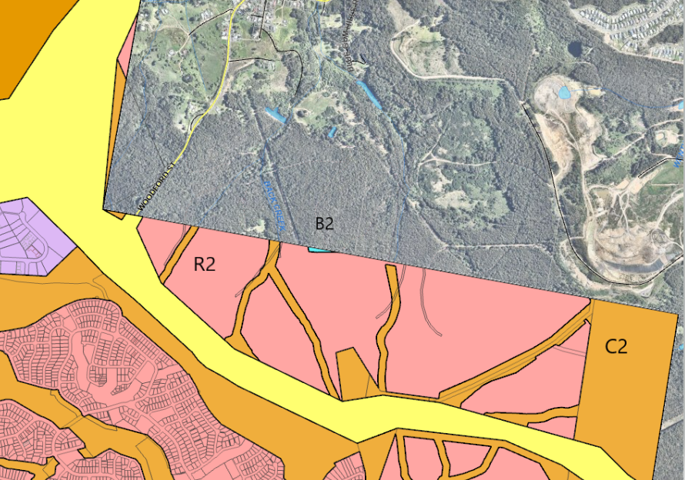
Figure 5: Zoning map extract (R2 shown in pink, C2 shown in brown, and B2 shown in blue)
3.5.2 Minimum subdivision lot size
The minimum lot sizes for each zone, and consideration of the development are detailed in Table 3.
Table 3: Minimum lot size consideration
LEP minimum lot size | Proposed lot size | Comply
Cl 4.1 - R2 zoned land - 450m² | All standard residential lots have a minimum area of 450m² or more. | Y
Cl 4.1B enables subdivision of land that creates 10 or more lots and at least 10% but no more than 50% of those lots to have area equal to or greater than 300m² but not greater than 450m² and be for the purposes of a dwelling house or semi-detached dwelling. | A total of 113 lots (which equates to 10%) are proposed which have areas equal to or greater than 300m² but not greater than 450m². | Y
Cl 4.1C corner lots requires corner lots to have an area of at least 500m² in R2 zone. | All corner lots, except the following meet the minimum corner lot size.  Nine corner lots do not meet the minimum LEP lot size (lots 1710, 1711, 1811, 1812, 1821, 1843, 2438, 3007 and 3138) having areas ranging from 419m² to 497m², however the provisions of an EPI do not have effect to the extent it is inconsistent with the terms of the Concept Plan approval.  As the Concept Plan and subsequent Link Road North Urban Design Guidelines provide minimum lot size controls that permit lots smaller than 450m², clause 4.1 does not have effect in this instance. | Y
Cl 4.1C battle-axe lots requires battle-axe lots to have an area of at least 600m² in the R2 zone. | Two battle-axe lots are proposed (Lot 1205 and 2912) which have area of 683m² and approximately 1000m². | Y
Cl 4.1D - Exceptions to minimum subdivision lot sizes for certain split zones  C2 zoned land – 40ha | The application proposes to create 13 conservation zoned lots.  Twelve lots do not achieve the minimum lot size and range from 2292m² to 33293m².  Lot 3050 has an area of 41 476m² and achieves the minimum lot size.  All conservation zoned lots are for public or drainage reserves.  Subdivision of C2 zone land is permitted as exempt development under Subdivision 38 of the State Environmental Planning Policy (Exempt and Complying Development Codes) 2008.  The SEPP permits the subdivision of land for the purpose of creating a public reserve (including drainage reserves), and no minimum lot size applies.  Whilst the lots do not achieve the prescribed minimum lot size in the C2 zone, the proposed subdivision is permitted as outlined above. | Y
Cl 4.1 - B2 zoned land – no minimum lot size | Lot 1201 has an area of approximately 3600m² which is considered sufficient to provide for its future development for commercial/business. | Y

Part Lot 4003 is located in the LMCC LGA and has an area of 22.572ha. The zone boundary for the lot is not fully understood and includes R2 zoned land, and may include a portion of C2 and SP2 zoned land. This is due to inconsistencies in the cadastral plan and exhibited LEP land use zone maps.
This administrative error between the zoning / cadastral maps is considered to be inconsistent with the Concept Plan, and thereby does not inhibit the development.
3.5.3 Arrangements for designed State public infrastructure
Pursuant to clause 6.1, development consent must not be granted for the subdivision of land in an urban release area if the subdivision would create a lot smaller than the minimum lot size permitted on the land immediately before the land became part of an urban release area, unless the Secretary has certified that satisfactory arrangements have been made to contribute to the provision of designated Sate public infrastructure.
A Certificate of Satisfactory arrangements was provided under the original application and this element is taken to be satisfied.
3.5.4 Public utility infrastructure
Pursuant to clause 6.2, development consent in an urban release area cannot be issued unless the consent authority is satisfied suitable arrangements for public utility infrastructure (water, sewer and electricity).
Public utility infrastructure is available to the development. Refer to section 4.13 of this report for detailed assessment.
3.5.5 Development control plan
Pursuant to clause 6.3, development consent must not be issued for development on land in an urban release area unless a development control plan (DCP) has been prepared for the land.
Urban Design Guidelines (UDG) have been adopted for the development in association with the Concept Approval. These guidelines are the equivalent of a DCP for the site.
All land, except Lot 4003 is subject to the Link Road North Area Plan (the adopted UDG for LMCC). Lot 4003 is subject to the Minmi Precinct Development Guidelines UDG however no controls under the UDG are relevant as the lot is proposed as a future development lot.
The proposal is generally consistent with the UDG. Refer to Attachment B for detailed assessment of the UDG.
3.5.6 Earthworks
Pursuant to clause 7.2, development consent is required for earthworks.
The application proposes earthworks across the site for remediation of the site from contamination and mine subsidence, construction of roads, stormwater facilities and utility services, establishment of asset protection zones (APZs), regrading to achieve maximum APZ grades, and regrading of residential lots to establish lots suitable for future dwellings. Retaining walls within the site range between 1-5m in height for roads and boundaries. Typical retaining to residential lots has been demonstrated.
The design, placement and aesthetics of earthworks and retaining walls are considered satisfactory and consistent with the provisions of this clause.
Refer to section 4.6, 4.7 and 4.8 of this report for detailed assessment.
3.5.7 Flood planning
Pursuant to clause 7.3 (now clause 5.10), development consent must not be granted to land that is flood prone unless the consent authority is satisfied the development is compatible with the flood hazard of the land, will not significantly adversely affect flood behaviour, incorporates appropriate measures to manage risk to life from flood, and not have adverse environmental impacts.
The site is not identified as flood prone, however localised flooding is experienced from catchments within the site.
A flood impact assessment has been submitted with the application which identifies the development will not be adversely impacted by flooding, or cause adverse flooding impacts. The report identifies all residential lots and park lots are located outside of the 100 year flood event, all road crossings are located outside of, or above the 100 year flood level, and safe evacuation is achievable, and stormwater management facilities have been designed to demonstrate peak flows leaving the site to be similar or less than those leaving the site currently during storm events, and not having adverse impacts.
Refer to section 4.9.1 of this report for detailed assessment.
3.5.8 Development on sensitive Aboriginal landscape areas
Pursuant to clause 7.7, for development located on land identified as sensitive Aboriginal landscape area, the consent authority may require an Aboriginal Heritage Impact Statement.
The site maintains one Aboriginal site, which is located in a riparian corridor and proposed to be protected in situ. Documentation addressing impact of the development to Aboriginal cultural heritage has been submitted with the application, demonstrating the development will not have adverse impacts.
Refer to section 4.2 of this report for detailed assessment.
3.5.9 Essential services
Pursuant to clause 7.21, development consent must not be granted to development unless the consent authority is satisfied water, electricity, sewer, stormwater drainage and vehicle access is available or adequate arrangements have been made to make them available.
All essential services are available to the development. Refer to section 4.13 of this report for detailed assessment.
3.6 Provisions of any proposed instruments
There are several instruments, including draft SEPPs that were draft instruments during the assessment period of the application, however have since been adopted. Refer to section 3.4of this report for detailed assessment.
3.7 Provisions of any Development Control Plan
Ordinarily, the Lake Macquarie Development Control Plan 2014 (LM DCP 2014) would apply, however the Link Road North Area Plan and Minmi Precinct Development Guidelines, which act as UDG, have been adopted for the development in association with the Concept Approval.
A summary of the key matters for consideration arising from the UDG are outlined in Table 3. Refer to Attachment B for detailed assessment of the UDG. Note, no controls under the Minmi Precinct Development Guidelines UDG are relevant to Lot 4003 as the lot is proposed as a future development lot.
Table 4: Summary of UDG controls
Control | Consideration | Comply
Subdivision design and layout | The development includes a layout that is generally consistent with the UDG | Y
Road design | Road design is generally consistent with the UDG | Y
Lot configuration | All lots meet the required minimum area and dimension | Y
Cut and fill | The extent of cut, fill and retaining is considered acceptable both in terms of engineering and amenity outcomes. | Y

3.8 Planning agreements under Section 7.4 of the EP&A Act
3.8.1 Concept Approval planning agreement
A planning agreement was entered into under Section 93F (now Section 7.4) of the EP&A Act by the landowners (Winten (No 21) Pty Ltd and Minmi Land Pty Ltd and the State, in September 2018.
The Planning Agreement applies to the entirety of the Minmi Lands covered by the Concept Approval, and includes:
- The payment of a monetary contribution to the Minister
- Dedication of education lands, and
- Dedication of regional open space.
The State VPA will also be amended to include regional road network upgrades as negotiated between the applicant and TfNSW during the review application. This process has commenced and endorsement has been provided by the Department of Planning and Environment (DPE) to the amendment. Conditions of consent will be imposed to ensure the development is delivered as per the State VPA.
3.8.2 Development application planning agreement
The applicant has offered to enter into a draft planning agreement under Section 7.4 of the EP&A Act.
In lieu of monetary contributions under s7.11 the planning agreement proposes:
- Monetary contribution of $11,500,000 for construction of two sports fields, and two new sports courts and upgrade of two existing sports courts, including floodlights.
If the facilities do not amount to this cost, the residual money is to be retained by Council to spend on other open space and recreational facilities.
- Dedication of land for two local parks.
- Construction of two playgrounds within the local parks.
- Construction and dedication of a shared pathway within the site.
The shared path will be completed and dedicated to Council in conjunction with the progressive opening of the subdivision.
- Residual monetary contribution.
A letter of offer to enter into the draft planning agreement, and for the draft planning agreement to be placed on public exhibition, has been endorsed by the elected Council on Monday 27 November 2023.
It is understood the RPP are able to progress to determine the application with the above endorsement. If the application is approved, a VPA will be drafted in accordance with the endorsed letter of offer.
A conditions of consent will be imposed to ensure the development is delivered as per the VPA.
3.9 Provisions of Regulations
The Environmental Planning and Assessment Regulation 2021 (EPA Reg 2021) contains matters that must be taken into consideration by a consent authority in determining a development application.
No additional matters are relevant to the proposed development.
3.10 Likely impacts of development
The likely impacts of the development, including environmental impacts on both the natural and built environments, and social and economic impacts have been considered as outlined above and the key issues section below.
3.11 Suitability of the site
The site is considered suitable for the proposed development. The development is consistent with a Concept Approval for the land aimed at facilitating supply of suitably located and serviced residential land. Site constraints have been appropriately addressed and managed as detailed throughout this report.
3.12 Public submissions
The review was notified in accordance with the Council’s LMDCP 2014 and Council’s Community Participation Plan on the following occasions:
  - 6 February 2023 – 28 February 2023
  - 6 October 2023 – 27 October 2023
  - 1 November – 22 November 2023
Five submissions were received, one to the initial round, one for the second round, and three for the third round.
The issues raised in these submissions are considered in Table 5.
Table 5: Community submissions
Issue | No. | Council comments
Impact to operations of the SWMC as a regional waste facility.  Objections have been received from CN regarding the potential impact of the development to the operation of the facility, and particularly the future southern access road which provides an opportunity for a new entry/exit to the facility.  Objections are requesting a suitable buffer is implemented to ensure the future access is not compromised from adjacent residential development.  Objections are requesting a 1000m buffer is implemented to ensure the future operations of the landfill, potentially up to a further 80-130 years, is not comprised from adjacent residential development, odour, acoustic, gas impacts. | 3 | The application has demonstrated the development will not be adversely impacted by noise or odour impacts generated by the SWMC facility.  The development does not compromise the ability for a future access road to be provided.  Refer to section 4.3.1 and 4.10 of this report for detailed assessment.  The applicant has also provided a detailed response to the submission which addresses how the development has addressed any future access road.
Inconsistency with Concept Approval condition 1.34.  Objections have been received regarding the interpretation of ‘waste servicing vehicles’ specified in condition 1.34 of the Concept Approval.  The submitter argues the condition caters for up to B-Double sized vehicles.  The submitter argues the condition reference to ‘relevant council’ means City of Newcastle. | 3 | Council considers the condition to be satisfied with the collector road network within the subdivision being suitable for waste servicing vehicles.  Refer to section 4.10.2 of this report for detailed assessment.  The applicant has also provided a detailed response to the submission which responds to the submitter’s concerns of heavy vehicles on the key route proposed.
VPA / recreation facilities  A submission was received from CN, objecting to the updated arrangements for provision of recreation facilities provided by the applicant on 19 October 2023. | 2 | It is noted the updated arrangements were endorsed by the DPE as being consistent with condition 1.16 of the Concept Approval. Statutory requirements for the arrangements have been met.

3.13 Agency referrals and concurrence
The development is not integrated development as the terms of the Concept Approval apply.
The Concept Approval requires the following requirements to be met:
- Condition 1.16 – Department of Planning Secretary to be satisfied as to recreation facilities arrangements.
- Condition 1.20 – Office of Environment and Heritage – management procedures for interface to Blue Gum Hills Regional Park and riparian land.
- Condition 1.30 - Subsidence Advisory NSW – requirement for mine subsidence / pothole risk assessment.
- Condition 1.31 – Transport for New South Wales – traffic assessment and intersection upgrades.
- Condition 1.35 – Office of Environment and Heritage – conservation management plan.
- Condition 1.36 – Office of Environment and Heritage – heritage interpretation strategy
- Condition 1.37 – Office of Environment and Heritage – European archaeological investigations.
- Condition 1.38 – Office of Environment and Heritage – Aboriginal heritage management plan.
- Condition 1.45 - NSW Rural Fire Service – requirement for a Bushfire Management Plan to the satisfaction of the RFS.
- Condition 1.47 – TransGrid – requirement to show any requirements in relation to Newcastle – Tomago 330kV transmission line have been met.
The development application has been referred to the various agencies as outlined below in Table 6. Further details are also included in Attachment A, with respect to the relevant Concept Approval condition.
Table 6: Referrals to agencies
Agency | Referral trigger | Comments | Resolved
Department of Planning Secretary (DPE) | Condition 1.16 of Concept Plan Approval | Response received from DPIE (October 2023) confirming approving suitable locations for recreational facilities for the Lake Macquarie application. | Y
Biodiversity and Conservation Division (DPE) (OEH) | Condition 1.20 of Concept Plan Approval | The NSW Biodiversity Conservation Division (BCD) are generally supportive of the amended application and have recommended some aspects of the Vegetation and Habitat Management Plan be amended to reflect best practice. The majority of these recommendations have been accepted by the applicant. | Y
SA NSW | Condition 1.30 of Concept Approval | The applicant has engaged directly with SA NSW to satisfy outstanding matters from the authority’s assessment. Endorsement from SA NSW has been provided, date 25 May 2023. | Y
TfNSW | Condition 1.31 of Concept Approval | Endorsement has been provided by TfNSW subject to state and local road network upgrades, which will be imposed through conditions of consent. | Y
 | Clause 104 – Infrastructure SEPP – traffic generating development
Heritage NSW | Condition 1.35 of Concept Approval | Response received from Heritage NSW under the original application confirming they are satisfied with the development, noting the site does not contain any European heritage items, and recommended conditions regarding unexpected finds. | Y
 | Condition 1.36 of Concept Approval
 | Condition 1.37 of Concept Approval
 | Condition 1.38 of Concept Approval | Response received from Heritage NSW under the original application confirming they are satisfied with the development, and recommended conditions of consent regarding AHIP applications, if required. | Y
NSW RFS | Condition 1.45 of Concept Approval | The original application was referred to NSW RFS who raised no objection to the development and recommended conditions regarding BAL levels, APZs, road construction, utility provision and landscaping.  Confirmation of the RFS endorsement was obtained under the review application. | Y
TransGrid | Condition 1.47 of Concept Approval | The original application was referred to TransGrid who raised no objection to the development and recommended conditions regarding construction related matters. | Y

The original application was also referred to Ausgrid under clause 2.48 of the Transport and Infrastructure SEPP. Ausgrid raised no objection to the development and recommended conditions for upgrading of existing infrastructure to cater for development.
3.14 Public interest
The development:
- comprises a lawfully permitted land use, consistent with a state government approved concept plan for the site and surrounds.
- demonstrates consistency with relevant statutory considerations.
- appropriately manages applicable site constraints ensuring the suitability of the land for the proposed use.
- effectively considers, and responds to, the site context and surrounding features.
- contributes to the supply of suitably serviced and located residential land to the region.
Accordingly, the development is considered to be in the public interest.
- KEY ISSUES
The following key issues are relevant to the assessment of the review application having considered the relevant planning controls and the Panel’s previous comments during assessment of the original application.
4.1 Concept Approval
Applicable conditions under the Concept Approval have been addressed through provision of updated information submitted under the review application.
Details of the assessment of the Concept Approval are included in Attachment A.
4.2 Aboriginal heritage
The site maintains one Aboriginal site, which is located in a riparian corridor and proposed to be protected in situ. All other five sites identified during the Concept Approval assessment have since been updated as having been destroyed following multiple attempts to locate the sites in preparation for the original application.
Condition 1.36 of the Concept Approval requires a heritage interpretation strategy to be provided that addresses interpretation of Aboriginal heritage throughout the development, including identifying opportunities for long term storage and display of archaeological relics. The strategy is to be prepared in consultation with the OEH (now Heritage NSW), and Council.
A heritage interpretation plan, prepared by a conservation practitioner has been submitted with the application. The plan includes a detailed history of the whole Concept Approval site and includes Aboriginal heritage interpretation strategies. The application has been referred to OEH (now Heritage NSW) who raised no objection to the development and recommended conditions of consent relating to Aboriginal heritage impact permit (AHIP).
Condition 1.39 of the Concept Approval requires the application to demonstrate all reasonable effort has been made to avoid impacting Aboriginal cultural heritage. Where impacts are unavoidable, requirements for legislative approvals are to be addressed, and mitigation measures are to be negotiated with the local Aboriginal community, and all sites impacted must have an OEH Aboriginal Heritage Site Recording form completed and submitted to OEH within three month of completion of the Aboriginal cultural heritage works.
An Aboriginal cultural heritage management plan (ACHMP) has been submitted with the application, which was undertaken in consultation with the Registered Aboriginal Parties and OEH. The report demonstrates the proposal has been designed to avoid impact to the registered site and recommends works in proximity to the site are avoided. This outcome can be addressed through the imposition of an appropriate condition of consent.
Condition 1.40 requires an Aboriginal Cultural Education Program be developed and implemented in consultation with the local Aboriginal Community, for the induction of all personnel and contractors involved in the construction activities on site, prior to commencement of works. This outcome can be addressed through the imposition of an appropriate condition of consent.
The statement of commitments also requires prior to commencement of works, development of a procurement policy in conjunction with the indigenous community, for works during construction and ongoing maintenance, which incorporates initiatives to encourage local employment opportunities, including Aboriginals for the duration of the project. This outcome can be addressed through the imposition of an appropriate condition of consent.
The statement of commitments also requires prior to commencement of works an Aboriginal heritage plan of management (PoM) to be submitted in accordance with the heritage mitigation measures outlined in the heritage impact statement submitted with the Concept Approval, and include consultation with local Aboriginal stakeholder groups during the preparation of the Cultural Heritage Management Plan (CHMP) and throughout the development program, an updated AHIMS search to ensure all newly identified sites are included, ensure appropriate information, stop work, recording, and corrective action procedures are in place during construction, and implementation of heritage interpretation strategy. This outcome can be addressed through the imposition of an appropriate condition of consent.
It is noted an Aboriginal heritage management plan is already in place for the development, as was required by Condition 1.38 of the Concept Approval prior to the approval of any development application.
  - Acoustic impact
Condition 1.41 of the Concept Approval requires each application to outline strategies for impact of traffic noise on future residents, and restricts the use of acoustic barriers to Newcastle Link Road.
Condition 1.42 of the Concept Approval requires each application to assess the impact of increased traffic noise on all existing residential areas.
The statement of commitments requires an acoustic statement detailing measures to reduce road traffic noise for development along the Newcastle Link Road.
A traffic noise assessment has been submitted with the application. The report considers future residents, as well as the existing residences in the vicinity of the site and details the following acoustic outcomes:
- The majority of future dwellings will not be adversely affected by traffic noise and can achieve relevant internal noise criteria when constructed with standard building materials
- No mitigation is required as a result of traffic noise from the Newcastle Link Road.
- Several lots adjoining Woodford Street and the internal boulevard will exceed the relevant internal noise criteria, as shown in Figure 6.
Lots adjoining Woodford Street and on the eastern side of the internal boulevard are not expected to require acoustic attenuation to future dwellings, as the noise criteria is only exceeded for the rear of these lots where rear setbacks apply.
As a precautionary measure, conditions of consent could be imposed to address any residential building within the affected portion of these lots.
Lots on the western side of the internal boulevard require attenuation features that include:
  - thickened (minimum 4mm) monolithic glass (openable) and standard weather seals (category 1)
  - thickened (minimum 6mm) monolithic glass (openable) and full perimeter acoustic seals (category 2)
  - thickened (minimum 6mm) laminated glass (openable) and full perimeter acoustic seals (category 3)
This outcome can be achieved through the imposition of appropriate conditions of consent requiring a covenant on these lots.
- Noise assessment of existing traffic volumes identifies exceedance of the relevant noise criteria to existing residents for day and night periods. Traffic generated by the development will not increase existing levels by more than 12dB, which is consistent with the relevant noise policy for both day and night assessment periods, and no noise mitigation to existing residences is required.
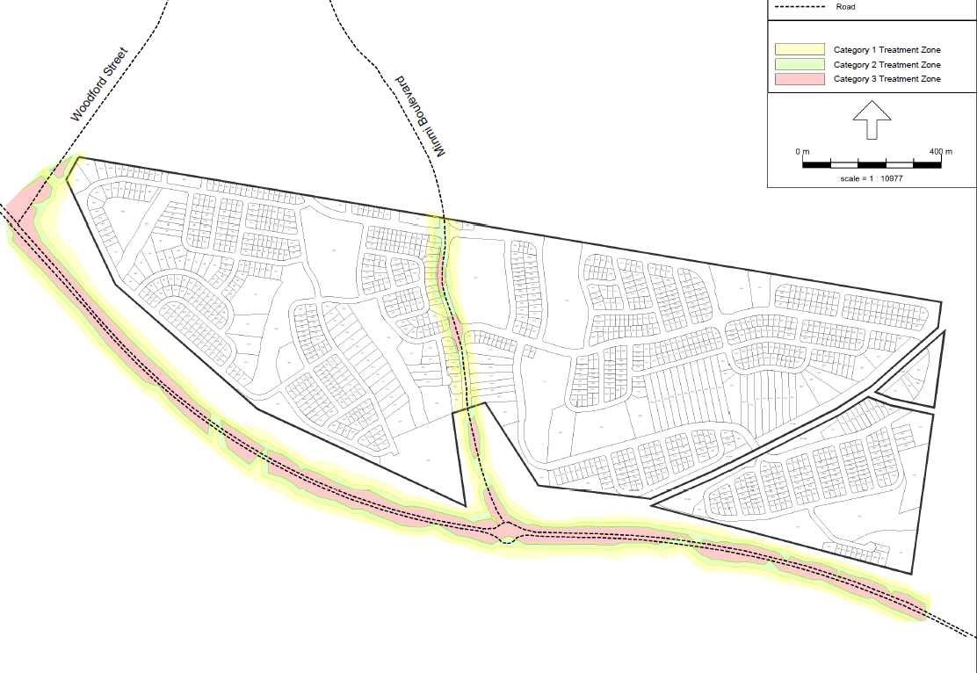
Figure 6: Acoustic attenuation plan
4.3.1 Summerhill Waste Management Centre acoustic impact
An acoustic assessment has been submitted with the application that addresses potential noise from the adjoining SWMC (i.e. reverse alarms, truck and plant movement within the facility). The report identified the measured noise was below the default Noise Policy for Industry (NPI) criteria. No mitigation measures are required to attenuate noise generated by the SWMC.
Objections have been received from CN requesting a suitable buffer (1000m is suggested) to ensure the SWMC is not compromised from adjacent residential development. The assessment demonstrates no mitigation measures are required.
4.4 Biodiversity
Following approval of the Concept Plan, the DPE provided certification in 2019 under clause 34A(3) of the Biodiversity Conservation (Savings and Transitional) Regulation 2017 certifying the development has appropriately considered and mitigated biodiversity impacts associated with the development up until 25 August 2017.
During the assessment of the original application, advice in relation to the s34A(3) Biodiversity Certification was provided from the Panel Secretariat regarding the extent of further flora and fauna investigation to meet the legislative framework. The advice confirmed Part 4, including former sections 5A, 78A, 79B and 79C, of the EP&A Act applies and assessment is required to be undertaken to determine whether a species impact statement (SIS) needs to be submitted for newly listed or up-listed species. In applying 5A of the EP&A Act, the consent authority must consider not only the factors under that section but also the VPA (dedication of 1,561 hectares of conservation lands) and the conditions of the Concept Plan Approval.
The application proposes to clear approximately 150 hectares of vegetation, minus vegetation within riparian corridors zoned conservation, and retain vegetation on lands with steeper slope. Clearing is primarily as a result of earthworks for construction of roads, stormwater facilities and utility services, establishment of APZs, regrading to achieve maximum APZ grades, and regrading of residential lots to establish lots suitable for future dwellings. Where APZs do not require regrading, selective thinning will occur to enable vegetation to be retained within residential lots.
Two species were identified as being within the scope of the above advice from DPE, being Scrub Turpentine (Rhodamnia rubescens) and the up-listed species Koala (Phascolarctos cinereus).
4.4.1 Scrub Turpentine (Rhodamnia rubescens)
Scrub Turpentine (Rhodamnia rubescens) was designated as a Critically Endangered Species in 2019 due to the proliferation of the Myrtle rust (Austropuccinia psidii) infection, a highly invasive fungal plant disease.
During assessment of the review application, Council requested further information from the applicant regarding the capacity of the development to cause a significant impact on the local population of Scrub Turpentine, particularly with regard to:
- the sufficiency and extent of survey efforts previously undertaken; and
- consideration of the health of the population, including the impacts of Myrtle rust.
The applicant undertook targeted surveys both on the development site and conservation lands in January 2023. Given the size of the conservation lands (1561 hectares), a conservative modelling methodology was employed to calculate the total number of individual stems present. Surveys of the development land identified 1,932 stems, 1,665 of which will be impacted by the proposal. For the conservation lands, 7,679 stems were directly identified, leading to an estimated total population of 17,878. All observed species on both sites showed signs of being infected with Myrtle Rust.
The applicant’s assessment of significance identifies:
- All stems within the development site showed signs of being infected with Myrtle Rust. There are no attributes of the stems on the development site that make them more preferable for retention than any other in the local population.
- The total impact arising from the development is relatively small in comparison to the amount being retained on the conservation lands, and the size of the local population overall.
- The proposal does not exacerbate the risk of extinction of the species.
The applicant’s assessment and contentions are supported. The reasoning for the uplisting of Scrub Turpentine predominantly relates to the impacts of Myrtle Rust. It is not within the scope of this development to resolve the issue of Myrtle Rust infection, moreover to assess whether there are any particular characteristics of the individuals impacted by the development that amplify their retention value. No such observation has been recorded in the extensive survey efforts undertaken for the proposal.
4.4.2 Koala (Phascolarctos cinereus)
Re-assessment of potential impacts on koalas is necessitated through the imposition of State Environmental Planning Policy SEPP (Koala Habitat Protection) 2020. The 2020 SEPP was implemented without savings and transitional provisions while the development application was under assessment, and applies to the application.
The main factor to be considered under the SEPP is whether the development site is Core Koala Habitat. This is the same threshold that needed to be met under the original application, which was assessed against the provisions of SEPP 44 (Koala Habitat Protection).
The applicant has undertaken additional surveys over four weeks in July and August 2023. Two Koala sightings were made during spotlight surveys in July, approximately 700 meters apart and six days apart. It was considered likely this was the same individual traversing across the site. No evidence associated with a koala population (e.g. scat) was observed during spotlight assessments.
These findings and observations are consistent with the findings under the original application, indicating there has not been a substantive change in circumstances for the site in terms of Koala habitation. The applicant’s expert report concludes the observed individual was likely a transitory individual moving between sub-populations; Council supports the conclusion the site does not contain a koala population and therefore does not comprise Core Koala Habitat.
4.4.3 Concept Approval condition 1.20 and statement of commitments
Condition 1.20 of the Concept Approval requires each application to include details of strategies to avoid and minimise clearing and disturbance of vegetation where possible, management measures for minimising impacts on fauna during subdivision works including the implementation of appropriate tree clearing protocols, details regarding the management of the interface between the site and the conservation lands, BGHRP and riparian land, with management procedures to be prepared in consultation with OEH and be carried into a VHMP.
The statement of commitments also requires trees of significance and trees within riparian corridors to be protected, wherever feasible.
The application has minimised clearing and disturbance of vegetation, to the extent possible, and proposes to retain vegetation within riparian corridors zoned conservation, and retain vegetation on lands with steeper slope. Clearing is primarily as a result of earthworks for construction of roads, stormwater facilities and utility services, establishment of APZs, regrading to achieve maximum APZ grades, and regrading of residential lots to establish lots suitable for future dwellings. Where APZs do not require regrading, selective thinning will occur to enable vegetation to be retained within residential lots.
The application has been referred to OEH (now Biodiversity and Conservation Division (BCD)) who raised no objection to the development and recommended some aspects of the VHMP be amended to reflect best practice. The majority of these recommendations have been accepted by the applicant with the exception of:
- scheduling the clearing works for a time of year to avoid the breeding seasons of identified potential threatened species that may breed on site, and
- tree clearing not being conducted above 35°C for the interests of animal welfare.
These matters were raised as recommendations by BCD and are not considered central to the satisfaction of condition 1.20. Council accepts the applicant’s position that enforcement of these particular elements would unreasonably burden the delivery of the development.
The statement of commitments requires prior to any works commencing, a VHMP is to be implemented requiring direction and supervision be provided by suitably qualified persons associated with vegetation removal, recovery of any native fauna that are potentially displaced, clearing protocol, selection of species to locally occurring native species for future landscaping works and seed stock for revegetation, completion of earthworks and works in the vicinity of drainage lines undertaken during appropriate weather conditions to minimise potential erosion impacts, and implementation of nutrient and sediment control devices. This outcome can be addressed through the imposition of an appropriate condition of consent, and it is considered that enforcement of such a condition would address the majority of BCD’s recommendations.
4.5 Bushfire protection
Condition 1.45 of the Concept Approval requires a bushfire management plan to be submitted that demonstrates the development complies with the Planning for Bush Fire Protection 2006 (PBP) and to the satisfaction of the NSW Rural Fire Service (RFS), and provides detailed arrangements for a road network and lot layout appropriate for evacuation purposes, property access roads which allow for the safe access, egress and defendable spaces for emergency services, location and composition of all APZs, ongoing maintenance requirements for APZs, fire trails and access tracks, and staged approach to management of bushfire hazard and APZs during the development process.
A bushfire assessment in the form of a bushfire management plan has been submitted with the application. The report details the following range of bushfire protection measures to be included in the subdivision:
- Perimeter roads throughout the subdivision, connections to existing fire trail network, and road network design that provides for defendable spaces, evacuation and safe access/egress
- Provision of APZs within residential lots or within the road reserve. APZs within residential lots will be identified on title through an appropriate easement. Where lots contain an APZ, the lots have been designed to ensure an adequate building envelope can be achieved.
No APZs are located on lands to be dedicated to Council for reserve purposes.
- Access to reticulated water supply, including fire hydrants
- Subdivision Building Attack Level (BAL) plan detailing the specific layout and protection measures for future development on the lots
- Strategically designed planting palette for public domain areas containing a combination of fire-resistant species.
- An APZ soil stability management plan to demonstrate APZs in escarpment areas or on slopes greater than 15 degrees, can be treated and maintained safely and without compromising slope stability
- Temporary APZs will be provided during construction of the development over the proposed stages comprising a 100m buffer
The application, including bushfire management plan was referred to the NSW RFS who support the proposal and recommended conditions in relation to BALs, APZs, road and fire trail construction, utility provision, and landscaping.
In accordance with clause 273B of the Environmental Planning and Assessment Regulation 2000, PBP remains the relevant prescribed document for all development applications made (but not determined) before 1 March 2020. The RFS have acknowledged this in their response to the original application, affirmed under the review.
The statement of commitments also requires a bushfire management plan prior to works commencing for each stage and be certified by a qualified consultant as complying with PBP and any requirements of the RFS. The plan is to address location of APZs (permanent and temporary), road and access design, building construction levels, location of habitat trees to be retained, areas of vegetation to be removed, retained or replaced, access to services and utilities, plant species, and preparation of fuel management plan. These matters have been assessed (i.e. APZs) or can be addressed through the imposition of an appropriate condition of consent.
4.6 Contamination
Clause 4.6 of the State Environmental Planning Policy (Resilience and Hazards) 2021 requires the consent authority to consider whether the land is contaminated, and if the land is contaminated, it is satisfied the land is suitable in its contaminated state (or will be suitable, after remediation) for the purpose for which the development is proposed to be carried out.
Condition 1.29 of the Concept Approval requires a remediation action plan to be provided with each subdivision development application which includes characterisation of the nature and extent of contaminated material within the subdivision area, details of the remediation strategy and management measures to ensure the land is suitable for the proposed land use, a validation plan, and details of compliance with the Contaminated Land Management Act 1997.
Three assessments relating to contamination have been undertaken and submitted with the original and review application including:
- Preliminary Contamination Assessment (PCA) (assessed the entire Concept Approval) in 2011
- Detailed Contamination Assessment (DCA) (assessed the LMCC site) in 2018
- Remediation Action Plan (RAP) (assessed the LMCC site) in 2022, including validation plan
Updated information regarding disposal strategies for excavated materials, including capping have also been provided under the review application.
These assessments identify the following contamination on the land:
- importation and use of fill of unknown origin or quality fill mounds and around mine shafts
- illegally dumped waste, including asbestos containing material
- potential use of hazardous building materials and potential storage and use of fuels and oils around former mine infrastructure
- potential for landfill gases emanating from SWMC
The RAP identifies the volume of contaminated material to be approximately 2000/3000m³ comprising 750m³ fill material from former mine areas, 50m³ mounded fill areas, 110m² historic mining activity and 1000m³ likely unexpected finds.
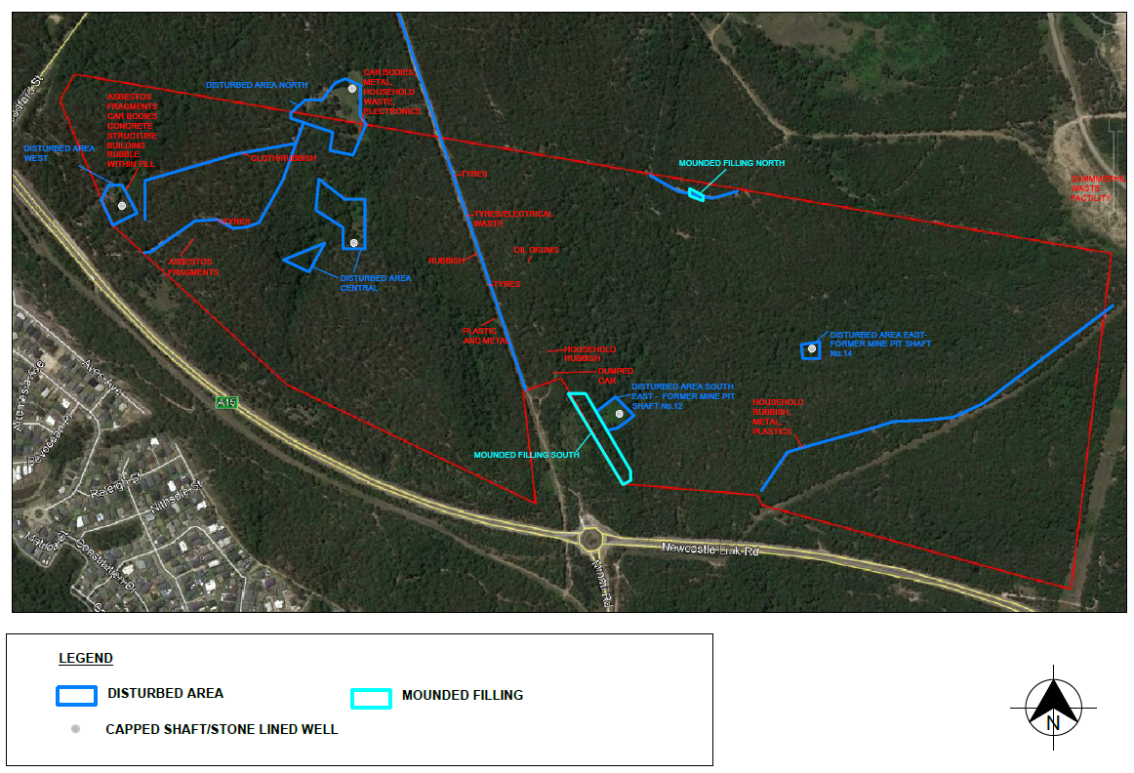
Figure 7: Location of contamination
The proposed remediation strategy is to cap and contain contaminated material on-site at depths greater than 2m or greater than 5m, depending on the categorisation of the contaminated material.
Where material is capped at less than 5m depth, a long term environmental management plan will be required and notations will be required to be included on the property’s planning certificate. This outcome can be addressed through the imposition of an appropriate condition of consent.
Potential locations for the capping have been nominated in the commercial land in Stage 12, with a secondary option in Stage 27 in circumstances where the commercial land is exhausted or closed.

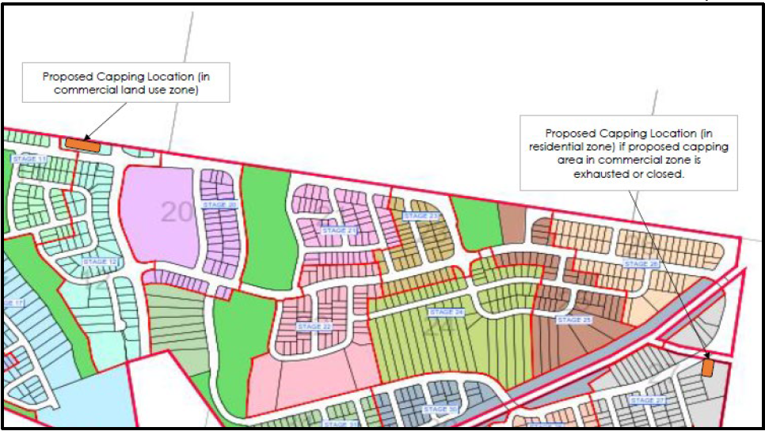
Figure 8: Proposed capping locations
The RAP also incorporates a suitable asbestos management plan.
The statement of commitments requires, prior to the issue of the SC for each stage detailed contamination assessment, a remediation action plan verified through the site auditor process, remediation conducted to remove identified contaminants, removal of deleterious materials, validation testing and verification, and waste classification of any materials disposed off-site. These matters can be addressed through the imposition of an appropriate condition of consent.
The RAP, through the implementation of the above measures, indicates the land can be made suitable for residential use following remediation. A condition of consent is to be imposed requiring the applicant to undertake a Site Audit in accordance with EPA requirements.
4.7 Earthworks
Condition 1.14 of the Concept Approval requires lots on land with greater than 25% slope to have an adequate area for a dwelling to be constructed on land which is not greater than 25% slope, and that vehicular access to the dwelling can be provided at a grade of not greater than 25%, and all lots on land with slope greater than 20% are at least 1,000m² in area.
The LM LEP 2014 requires consideration to be given to the likely impact of earthworks to drainage patterns and soil stability in the locality of the development, the effect of the development on the future use of the land and adjoining properties, the source and quality of fill, impacts to environmentally and cultural areas, and measures to mitigate impacts.
The UDG requires cut and fill to be responsive to the design constraints associated with the site topography. The UDG acknowledges significant earthworks will be required to accommodate required subdivision works including roads, drainage, detention basins and utility infrastructure.
The application proposes earthworks across the site for remediation of the site from contamination and mine subsidence, construction of roads, stormwater facilities and utility services, establishment of APZs, regrading to achieve maximum APZ grades, and regrading of residential lots to establish lots suitable for future dwellings. Retaining walls within the site range between 1-5m in height for roads and boundaries. Typical retaining to residential lots has been demonstrated.
Further details have been submitted regarding location and set back of retaining walls, particularly where adjoining site boundaries and future public reserves and potential vegetation impacts may arise. Council is satisfied that, subject to imposition of relevant conditions of consent, the retaining will not result in adverse impacts on adjacent trees or the amenity of the locality.
Lots 2911 and 2912 are to be consolidated as the proposed design does not provide an access grade that complies with Council’s requirements. A condition of consent will be imposed, which has been agreed to by the applicant.
The development is consistent with this condition of the concept approval subject to the imposition of conditions.
4.8 Mine subsidence
Stage 5 of the development comprises areas identified as having limited, moderate and high subsidence risks. The site does not contain any pothole risk areas.
Three capped mine shafts have been identified on-site. Two of the mine shafts are proposed within residential lots (Lot 1913 and 2458) and the third mine shaft is proposed within the land to be a public reserve (Lot 3146). The residential lots containing the capped mine shafts have been created as larger lots to enable suitable building areas to still be available on them. Covenants will also be placed on these lots to identify the shafts and restrictions on building.
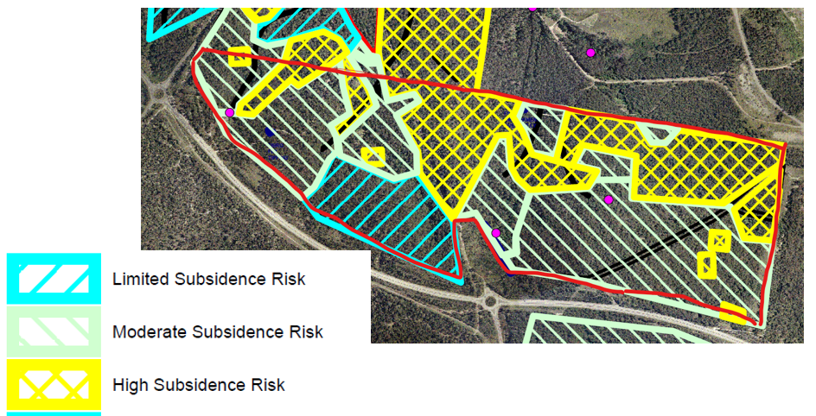
Figure 9: Mine subsidence risk mapping (capped mine shafts shown by purple dot)
Condition 1.30 of the Concept Approval requires geotechnical investigations to be submitted prior to issuing of any subdivision certificate, in accordance with the Mine Subsidence Board requirements (now SA NSW) to demonstrate the risk of mine subsidence can be removed and / or managed within the development site by suitable means, or demonstrate that the works are long term stable and there is no risk of subsidence, as appropriate to the intended future use of the land.
The statement of commitments requires additional investigations to address pothole risk, grouting, and depth of covering to workings, and ongoing consultation with SA NSW for each stage and/or lot.
Due to the potential impacts arising from these works and the final site layout and environmental outcomes, consideration of this matter is required to be undertaken and resolved during the assessment of the application.
The application proposes to manage subsidence risk through building design restrictions. No grouting works are proposed. The applicant proposes to address the requirements of Condition 1.30 at Subdivision Certificate (SC) stage.
The statement of commitments also requires restrictions on building height and construction, management of land containing shafts, plan of management for shallow mined areas, and detailed road design. These matters can be addressed through the imposition of an appropriate condition of consent.
The applicant engaged directly with SANSW to satisfy outstanding matters from the authority’s assessment, including provision of a geotechnical assessment. Endorsement from SA NSW, as well as required conditions of consent, were obtained on 25 May 2023.
4.9 Stormwater management and flooding
Condition 1.25 of the Concept Approval requires a water sensitive urban design (WSUD) strategy to be provided to consider how impacts from stormwater infrastructure are minimised on riparian corridors and waterways. The strategy is to be a strategic level document and demonstrate where possible stormwater infrastructure will be located off-line and outside of the identified riparian corridor (having regard for relevant NSW Office of Water guidelines relating to works within riparian corridors).
A WSUD strategy has been submitted with the application. The report provides guidance to inform the layout of the development to minimise impacts to the riparian corridors, design and location of permanent stormwater management facilities, guidance on mitigation of flooding impacts as a result of the development, and guidance on the design of temporary erosion and sedimentation during construction.
The NSW Office of Water guidelines recommend an average 10m vegetated riparian zone (VRZ) for 1st order watercourses and 20m for 2nd order watercourses. The site contains 1st and 2nd order watercourses, all of which are located within the conservation zoned land. Works such as road crossings and stormwater facilities, including basins are permitted in VRZs.
The application proposes to protect watercourses by:
- minimising the number of road crossings over watercourses, and inclusion of retaining walls (instead of batters) to road crossings
- including widened conservation corridors to include adjacent residential land to ensure earthworks and APZs do not impact the VRZ and conservation zoned lands where watercourses are located
- locating stormwater management facilities off-line from the adjacent watercourse.
Condition 1.26 of the Concept Approval requires detailed design that is consistent with Council’s requirements and the WSUD strategy for stormwater management infrastructure and devices. The statement of commitments also requires, as relevant, preparation of a groundwater management strategy and maintenance regime, lot detention for housing lots, mosquito risk and management assessment.
A stormwater management plan and associated civil engineering plans have been submitted with the application, which incorporates the WSUD strategy and provides detailed analysis to inform the sizing and design of stormwater management facilities throughout the development, including pit and pipe network throughout the subdivision, future rainwater tanks to residential lots, gross pollutant traps, infiltration systems and bioretention basins. The report demonstrates the range of stormwater management facilities will mitigate the impact of the quality and quantity of stormwater runoff from the development to levels that are consistent with Council’s guidelines and industry standards.
The mosquito risk and management assessment is not relevant to the LMCC application.
Condition 1.27 of the Concept Approval requires management arrangements to be provided for public stormwater facilities, during and after construction, prior to being dedicated to the relevant Council.
The statement of commitments also requires details on the proposed bio-retention basins, bio swales and swales, maintenance program for bio-swales, public stormwater system/basins, and transfer program to be submitted with the Construction Certificate (CC) application.
The stormwater management plan and associated civil engineering plans provide details of the stormwater management facilities, which are consistent with Council’s requirements. Council has standard conditions and management guidelines to ensure facilities to be dedicated are constructed and managed appropriately and will be acceptable as public assets after the initial maintenance period. These matters can be addressed through the imposition of an appropriate condition of consent.
4.9.1 Flooding
The site is not identified as flood prone, however localised flooding is experienced from catchments within the site.
Condition 1.23 and 1.24 of the Concept Approval requires the application to include flood modelling which addresses terrain information (i.e. digital elevation model), identifies any flooding effects associated with the Hunter River and ocean levels including any impacts associated with sea level rise, consideration of impacts on climate change on flood hazard, consideration of flooding impacts associated with the proposed development, and each lot can accommodate dwellings located above the flood planning level (100 year flood plus 0.5 metre free board with fill limited to the 0.5 metre free board only), safe evacuation can be provided from all dwellings and public land below the probable maximum flood level, through consultation with the relevant Council and State Emergency Service.
The statement of commitments also requires stormwater management measures to be included to manage flood risk according to the NSW Floodplain Development Manual.
A flood impact assessment has been submitted with the application. The report identifies all residential lots and park lots are located outside of the 100 year flood event. Only the public reserves containing watercourse corridors are impacted by the flood event. All road crossings are located outside of, or above the 100 year flood level, and safe evacuation is achievable.
The assessment also demonstrates the development will result in the peak flows leaving the site to be similar or less than those leaving the site currently during storm events, due to the design of the stormwater management facilities.
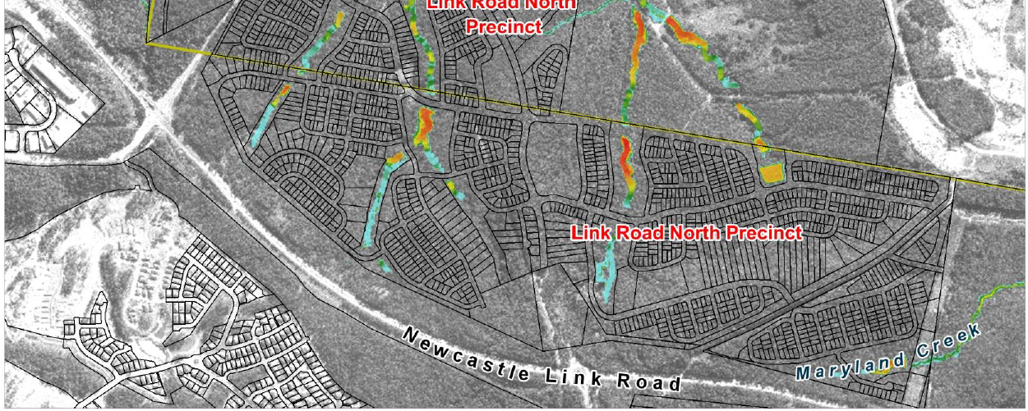
Figure 10: Extent of flood inundation during 100 year flood event (post development)
4.10 Summerhill Waste Management Centre
4.10.1 Odour impacts
Concept Approval condition 1.44 requires each development application for subdivision to consider odour impacts associated with the SWMC, and identify appropriate mitigation measures to manage these impacts.
Objections have also been received from CN requesting a suitable buffer (1000m is suggested) to ensure the SWMC is not compromised from adjacent residential development.
An odour assessment has been submitted with the application. The report identified the following:
- observed odour associated with the SWMC to be 255m from the boundary.
- the Environmental Impact Statement for SWMC requires a minimum 400m buffer between on-site potentially odour generating activities and sensitive land uses, with the retention of the vegetated buffer zone. The facility currently has an active landfill cell closer than 400m to the boundary of the subdivision site.
- 430m buffer from an active cell/s would be sufficient to mitigate the potential for odour at the boundary of the subdivision site.
In response to a request from Council’s Senior Sustainability Officer, the applicant provided a peer review of the originally submitted odour assessment. The peer review confirmed the suitability of the recommendations of the assessment from a suitably qualified and experienced expert, including nominated buffer zones.
Conditions of consent are recommended to ensure the subdivision staging is constructed to ensure the buffer is maintained.
4.10.2 Concept Approval condition 1.34
Condition 1.34 of the Concept Approval requires the application to demonstrate that key roads linking Minmi Boulevard and the waste management centre have been designed to accommodate waste removal vehicles in accordance with any requirements of the relevant Council, unless otherwise agreed to by that Council.
Objections have been received from CN regarding the interpretation of ‘waste servicing vehicles’ specified in condition 1.34 of the Concept Approval. CN argue the condition caters for up to B-Double sized vehicles, which could not be accommodated within the subdivision road network.
CN also argue the condition reference to ‘relevant council’ means City of Newcastle.
The applicant proposes to satisfy the condition as follows:
- Road MC58 is the key road that links Minmi Boulevard (Road MC01) and the SWMC
- Road MC01 and MC58 have been designed as collector roads, and can therefore accommodate all general vehicles up to a 19m semi-trailer. This includes waste removal vehicles, which has been taken to mean a vehicle purpose-built or adapted for waste removal.
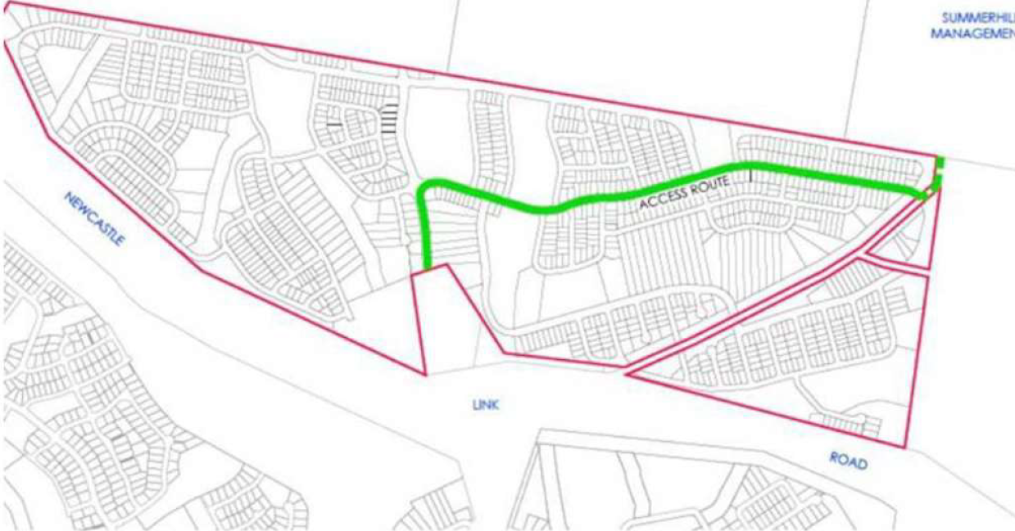
Figure 11: Proposed waste removal vehicle route
Council concur with the applicant’s interpretation of the condition and the condition relates to typical garbage trucks which can move through the subdivision. The collector road network, which also is a bus route, provides for waste removal vehicles. Civil engineering plans have been submitted which demonstrate the internal road network can cater for waste servicing vehicles.
The relevant Council is interpreted to apply to the Council of which the land is located within, being LMCC in this instance.
This position is supported by the previous RPP’s in the determination and statement for reasons.
4.10.3 Southern access to SWMC
Objections have been received from CN regarding the impact of the development to a future southern access road for light and heavy vehicles, within the unformed road corridor, which will provide an opportunity for a new entry/exit to the facility.
The road corridor is located within the LMCC LGA and is currently not formed. The corridor comprises the road reserved owned by LMCC, and TfNSW land. Forming of the roadway through an appropriate planning pathway and assessment, could provide vehicle access to the southern boundary of SWMC.
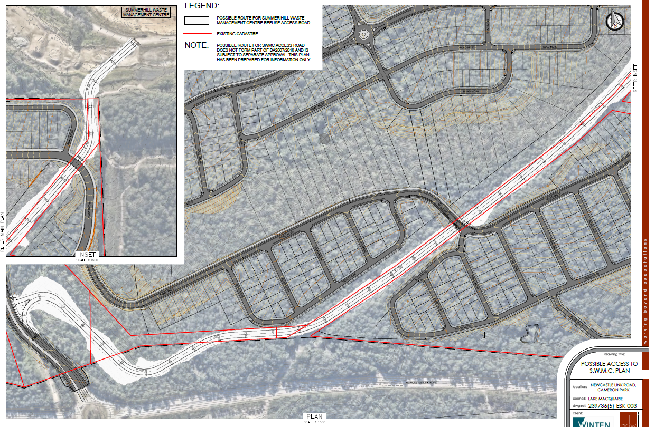
Figure 12: Indicative southern access to SWMC
The application has demonstrated a future southern access road to SWMC within the unformed LMCC road corridor will not be compromised by the development. The development provides a public reserve buffer to the road corridor. The roads within the subdivision that intersect with the road corridor, have been designed to go underneath any future access road, with an access road designed and constructed to be grade separated above. Environmental impacts, such as acoustic, visual, etc, would be considered during the planning assessment of the access road, which is likely to be a Part 5 assessment.
4.11 Traffic impact
4.11.1 Access and road network
Access to the development is provided by a new connection to the existing roundabout on Newcastle Link Road. Northern access is proposed via two connections to the proposed subdivision development in CN, which both provide connection to Woodford Street.
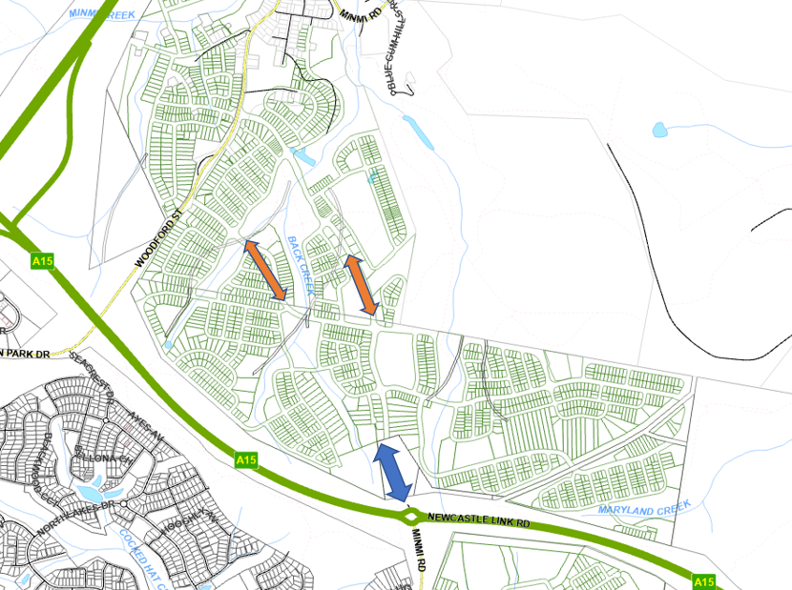
Figure 13: Access locations to development
(Link Road access shown in blue and northern access shown in orange)
Lots within the development will be accessed via the internal road network. No direct access from residential lots is proposed to the Newcastle Link Road, or the proposed boulevard on the internal road network.
Condition 1.32 of the Concept Approval requires all aspects of the local road layout and design meet the requirements of the relevant Council.
Civil engineering plans have been submitted with the application, which demonstrate a logical hierarchy for the road system, with local and collector roads in a modified grid layout proposed. The road grades, carriageway widths, intersection locations and configuration is consistent with Council’s requirements.
The application proposes a signalised intersection adjacent to the school site (Lot 2046) and commercial zoned land. Civil engineering plans demonstrating the intersection design has been submitted.
The proposed road network displays an appropriate level of detail and compliance for DA level endorsement. Conditions of consent are recommended to ensure that construction level documentation is prepared in accordance with Council standards.
4.11.2 Public transport
The internal road network has been designed to accommodate a bus route throughout the estate. Two options are proposed as a collector route, as demonstrated in Figure 14.
Consultation was undertaken with the bus service provider (Hunter Valley Buses) and TfNSW under the original application. TfNSW were supportive of either of the two options proposed
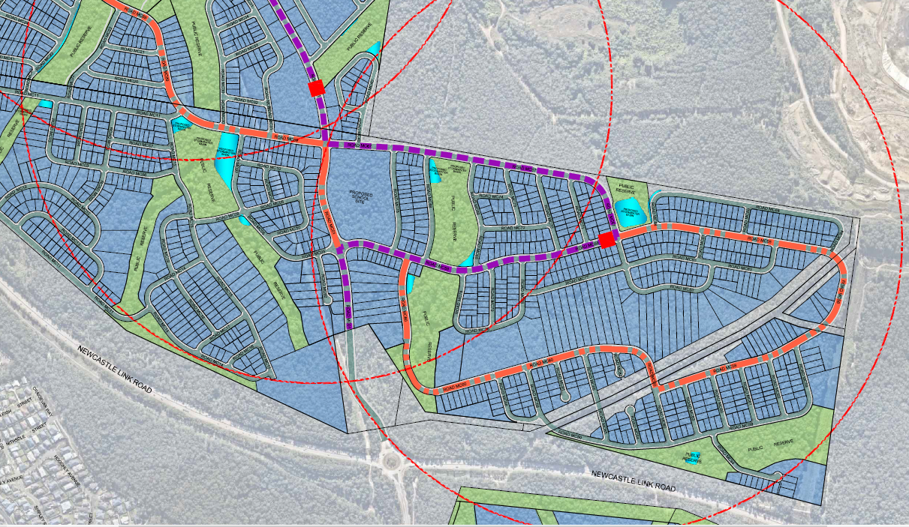
Figure 14: Bus route options
4.11.3 Pedestrian and cycle facilities
Pedestrian and cycle paths are incorporated throughout the subdivision and provide internal connectivity, as well as connections to BGHRP and other stages of the development.
These facilities have been incorporated into the road reserve widths demonstrated on the subdivision plans.
4.11.4 Concept Approval condition 1.31
Condition 1.31 of the Concept Approval requires the first development application for subdivision within each stage to include a revised traffic and transport impact assessment prepared in consultation with TfNSW and the relevant council(s). Each traffic assessment must include:
- details of traffic generation and distribution from all land uses proposed within that stage including retail, sporting facilities and education facilities.
- intersection analysis and micro-simulation modelling to determine the impact of the proposal on the existing regional and local road network.
- proposed timing for upgrades of key intersections, in particular Newcastle Link Road / Woodford Street / Cameron Park Road and Newcastle Link Road / Minmi Road in accordance with RMS requirements.
- details of any proposed upgrades to the road network, including timing and funding arrangements, to accommodate the proposed development. This is to include identification of suitable pedestrian links across Minmi Road and Newcastle Link Road.
A regional traffic and transport assessment and traffic impact assessment have been submitted with the application. The reports have undertaken microsimulation modelling that assesses the impact of the development’s traffic at years 2026, 2031 and 2036, and proposed road and intersection upgrades, staged as required, to be implemented to ensure the road network will operate at a satisfactory level of service during, and at the completion of the development.
The modelling identifies the following upgrades are required:
- upgrade from roundabout to signalised intersection of Newcastle Link Road / Minmi Road.
- widening of Minmi Road from Newcastle Link Road to Transfield Avenue from two to four lanes.
- installation of new roundabout at Minmi Road / Transfield Avenue.
- widening from two lanes to four lanes of Minmi Road from Transfield Avenue to Sedgwick Avenue.
- installation of additional turning lanes to Newcastle Link Road / Woodford Street.
- line marking changes to Minmi Road / Northlakes Drive.
- upgrade to Minmi Road / Main Road intersection to replace parking lane with traffic lane and link marking changes.
- upgrade Newcastle Link Road / Lake Road signalised intersection.
An agreement with TfNSW to facilitate the elements of the above works within the state and local road network has been reached. The agreement will be enforced as a condition requiring amendment of the existing State VPA prior to the issue of any Subdivision Works Certificate, and conditions of consent.
4.11.5 Statement of commitments
The statement of commitments also requires traffic studies being updated prior to commencement of each stage of development to reflect actual traffic yields, upgrades to intersections with collector roads as required by TfNSW/LMCC/CN, implementation of local traffic management measures where required, provision of bus stops, shelters and pedestrian refuges, provision of appropriate acoustic measures as agree with LMCC / CN, construction and embellishment of areas to be dedicated to Council in accordance with the specifications of the Concept Plan, and construction specifications of the appropriate Council.
These matters can be addressed through the imposition of an appropriate condition of consent.
The statement of commitments also requires CPTED principles to be addressed for each development application. The design and layout of the subdivision provides for casual surveillance throughout lot and road layout, and space management through appropriate landscaping of public assets. Access control, territorial reinforcement and space management will be achieved through the future residential development of the land where fencing, landscaping and access will be provided to individual lots.
4.12 Urban design
Condition 1.14 of the Concept Approval requires each application for subdivision to demonstrate lots on land with greater than 25% slope have an adequate area for a dwelling to be constructed on land which is not greater than 25% slope, and that vehicular access to the dwelling can be provided at a grade of not greater than 25%, and all lots on land with slope greater than 20% are at least 1,000m² in area.

Condition 1.15 of the Concept Approval requires each development application for subdivision to include a landscaping and public domain plan for the relevant stage, which demonstrates proposed open space, proposed treatments for open space and public domain, strategy for tree retention, landscaping of swales, detention basins, roadside verges and other public domain areas, management and ownership arrangements, and identification of appropriate landscaping species.
Landscaping reports and plans have been submitted demonstrating landscaping to public domain areas, including street tree planting, bioretention planting and planting of batters/embankments. Council’s Landscape Architect has reviewed the documentation and has imposed conditions of consent to achieve satisfactory outcomes.
The statement of commitments also requires future development to be carried out generally in accordance with the UDGs. Refer to Attachment B for detailed assessment of the UDG.
The statement of commitments also requires landscape plans to be provided prior to CC demonstrating retention of existing vegetation, to the extent reasonably possible, collection of seed so indigenous species are used in landscaping of parks, and use of recycled water in public parks, if feasible. These matters have been assessed (i.e. APZs) or can be addressed through the imposition of an appropriate condition of consent.
4.13 Utilities and servicing
Clause 6.2 and 7.21 of LM LEP 2014 require public utility infrastructure and essential services to be provided to the development (or made available).
The statement of commitments also requires water and sewer, underground power and NBN conduits to be provided.
The development includes the following utility and servicing infrastructure works:
- water and sewer
- electrical infrastructure
- gas infrastructure
- communications (i.e. NBN)
- road / intersection upgrades
Within the subdivision, utility services including water, sewer (including wastewater pump stations and rising mains), electrical infrastructure (including underground power, kiosks), gas, and telecommunications will be installed and connected to each residential lot. Utilities will be located within the road reserves. Street lighting will also be installed throughout the subdivision.
4.13.1 Water and sewer
A water and sewer strategy has been provided and approved by the Hunter Water Corporation (HWC). The strategy demonstrates water and sewer is located primarily within the site.
The strategy demonstrates the proposed land is capable of being suitably serviced.
The applicant has also undertaken a preliminary review of potential environmental impacts associated with the lead-in sewer and water infrastructure. It is acknowledged the strategy provides a high-level assessment of the capacity of the existing network to cater for the proposed development, with the exact location of physical works being subject to variation depending on the requirements of the infrastructure provider. Notwithstanding, the applicant has conducted preliminary ecological assessments based off a potential alignment of the works, which found that:
- the majority of vegetation mapped as Threatened Ecological Communities can be avoided.
- the alignment minimises disturbance on significant vegetation.
- all areas mapped as Coastal wetlands can be avoided.
- no other substantial environmental impacts including heritage, geotechnical stability or amenity are anticipated.
Council considers the above level of assessment to be satisfactory for DA purposes, noting that more detailed environmental assessment will likely occur as part of the approvals required for delivery of the infrastructure.
4.13.2 Electrical infrastructure
The site is traversed by three overhead transmission lines. An easement on the eastern boundary of the site contains a TransGrid 330KV transmission line. An Ausgrid transmission line is situated within the unformed public road reserve, while the other connects via the road at Newcastle Link Road towards Minmi township.
The development will involve the relocation of the existing Ausgrid transmission line. The application was referred to Ausgrid as per clause 2.48 of the Transport and Infrastructure SEPP. Ausgrid support the proposal and have a provided a response that details the requirements for the development, which can be achieved through conditions of consent (upgrading of existing infrastructure to cater for development).
The application was referred to TransGrid as per condition 1.47 of Concept Approval. TransGrid raised no objection to the development and recommended conditions regarding construction related matters.
4.13.3 Road / intersection works
Several intersection upgrades will be required to facilitate the development, as detailed by the applicant’s External Road Upgrade plan suite and the letter of agreement from TfNSW. The upgrades comprise:
- Provision of a signalised intersection at the Newcastle Link Road / Minmi Road intersection.
- Minmi Road from Newcastle Link Road to Transfield Avenue widened to four lanes total, including a roundabout at Transfield Avenue.
- Newcastle Link Road / Woodford Street:
  - Additional turning bays to achieve dual right turn movements on west and east approaches, including widening on exits to allow for safe merging.
  - Left turn bay on Newcastle Link Road (west approach).
  - Additional right turn bay on the southern and northern approaches.
  - Addition of new short through lanes on the northern and southern sides of Newcastle link Road at Cameron Park Dr and Woodford St.
- Minmi Road / Northlakes Drive: Line marking changes to allow a dual right turn on the western approach.
- Minmi Road from Transfield Avenue to Sedgwick Avenue: Widening to a total of four lanes and appropriate tie-in works at the roundabout at Transfield Avenue.
- Minmi Road / Main Road:
  - Conversion of the kerbside parking lane and cycle path into a general traffic lane.
  - Line marking changes to permit dual left turn lane from Minmi Road (north approach) into Main Road.
- Newcastle Link Road / Lake Road:
  - Addition of a new right turn bay on Lake Road (north approach).
  - Addition of a new left turn bay on Lake Road (south approach).
  - Extension of the left turn bay on Thomas Street.
Road upgrades are generally confined to disturbed areas within the existing road reserve and will thereby cause minimal environmental impacts. The applicant has also provided a preliminary assessment of potential environmental impacts as well as concept civil plans for the works that may impact upon existing vegetation. Notwithstanding the difficulty in conclusively estimating impacts from works, the applicant’s assessment concludes that:
- no impacts on threatened species or habitat trees are anticipated.
- the majority of works can be confined to existing disturbed areas.
- minor impacts on some areas of vegetation classified as an endangered ecological community may be required, however this will need to be confirmed once the final alignment of the upgrade works is resolved. At that stage, approvals associated with delivering the upgrade will give detailed consideration of potential impacts.
Provision of the above information enables an informed decision on the potential environmental impacts of the proposal in its totality, including off-site works. Notwithstanding potential variations through subsequent approval processes, it is considered the applicant has undertaken a reasonable and appropriate estimation of the likely impacts to support the Panel’s decision.
Council supports the proposed off-site works subject to applicable conditions and subsequent approval processes.
5 CONCLUSION AND RECOMMENDATION
The applicant has undertaken significant measures to address the matters raised by the Panel under the original application. Council considers the development now embodies an acceptable response to applicable planning controls, including alignment with relevant conditions under the Concept Approval, as detailed throughout this report.
Subject to the imposition of conditions outlined at Attachment C, Council considers the development to be worthy of approval and recommends the Panel amend the original determination to reflect this.

